**UAV Assisted Next Generation Wireless Communication Network**

Rahul Sharma

*Lovely Professional University,*

Phagwara, Punjab, India rahul.14289@lpu.co.in

*Shakti Raj Chopra

*Lovely Professional University,*

Phagwara, Punjab, India

shakti.chopra@lpu.co.in

Akhil Gupta

*Lovely Professional University,*

Phagwara, Punjab, India

akhil.20239@lpu.co.in

***Abstract—*One paradigm shift that has opened up new possibilities for connection and service provision is using Unmanned Aerial Vehicles (UAVs) in wireless communication networks. The main features and developments of next-generation wireless communication networks are helped by unmanned aerial vehicles. Unmanned Aerial Vehicle (UAV) deployment in wireless networks brings a new, adaptable architecture that solves problems with old ground-based systems. Using UAVs, it is possible to increase network performance by optimizing resource allocation, expanding coverage to remote places, and establishing temporary communication links. In this paper, we take a look at unmanned aerial vehicles (UAVs) and their possible deployment for optimal threshold limit by calculating signal-to-noise ratio (SNR) and frame error rate (FER), problems, and solutions in next-gen wireless communication networks.**

Keywords— Unmanned Aerial Vehicles, genetic algorithm, Frame error rate, signal-to-noise ratio.

# INTRODUCTION

Fifth-generation (5G) radio connection networks will replace current cellular networks, which are fourth-generation, and are expected to bring about the promise of seamless global connectivity. Over 150 billion wired and wireless devices are expected to be supported by 5G networks, which will also offer differentiated availability, bandwidth, and energy considerations [1]. The growth of the Internet of Things (IoT) and the launch of 5G and beyond 5G (B5G) have both had a significant positive impact on the demand for mobile data services. By 2028, it is predicted that monthly mobile internet traffic will shockingly increase to 1.6 zettabytes. The pressure on infrastructure and the effectiveness of networks will both be significantly raised as a result, leading to higher capital and operating costs. Using a range of microscopic cells, heterogeneous networks, sometimes referred to as HetNets, are early attempts to meet these ever-expanding demands [2.] These early efforts led to the emergence of HetNets. Unmanned aerial vehicles (UAVs), sometimes known as cellular UAVs [3], have come to be recognized as viable solutions in this situation. UAVs may be used for a variety of tasks, such as cargo transportation and defense support. Although the majority of recent research has been on using unmanned aerial vehicles (UAVs) to support mobile communications, other present use cases make use of UAVs that include navigational systems and specialized sensors. The development of Fly Ad Hoc Networks (FANETs), in which a colony of unmanned aerial vehicles (UAVs) cooperates to create broadband access networking across vast territories, has been studied in several studies [4,5]. To successfully address the location issues of base stations (BSs) on-demand, however, several challenges must be solved, particularly when grounded BSs are supplemented by unmanned aerial vehicles (UAVs). Several research projects have recently addressed the technological problems that are connected to UAV interactions. Topics including wireless coverage optimization, 3D positioning, user participation, and wireless UAV communication have been the main emphasis of these efforts. For instance, one research effort proposed architecture to determine the ideal number of drones to improve the quality of wireless coverage in particular places [6]. Another research examined the optimum strategy to deploy unmanned aerial vehicles (UAVs) in three dimensions [7]. Additionally, it was intended to strategically install several base stations supported by drones using wireless networking technologies to create a large ground network [8]. However, prior studies on the setting up of UAV ground stations occasionally failed to include the involvement of drone user terminals (UTs). These enhancements enable the developed algorithm to effectively solve the positioning challenges that emerge when BSs are deployed alongside UAVs. The program outlines an innovative method for using UAVs to help build cellular ground stations as efficiently as possible. Unmanned aerial vehicles (UAVs) acting as airborne ground stations have been the subject of several investigations to determine whether they may increase data transmission and offer a hybrid cellular network design [9]. By enhancing device-drone interaction and allocating spectrum for mobile broadband service, various studies have sought to improve land usage [10]. In a different study, the researchers created a novel method of cell association that increased the overall data gathered from drone-based sensors while at the same time shortening the time ground users were in the air [8]. Together, these numerous initiatives are influencing the development of UAV-assisted communication networks, which aim to achieve higher levels of performance and efficiency. In conclusion, the landscape of future radio communication networks driven by 5G will transform how the world communicates, and UAVs will be crucial to addressing the demands of the Internet of Things and other emerging technologies. In response to the rising number of network issues, research activities are concentrated on enhancing the deployment of UAVs as airborne base stations. This prompted the creation of original algorithms and optimization techniques. UAVs have a lot of promise to expand coverage, increase capacity, and provide a reliable and seamless connection for a wide range of applications when they are integrated into wireless communication networks.

1. RELATED WORK

The issue of trajectory design and UAV deployment has received extensive attention in the literature. Rather than serving a vast number of consumers to assist high-priority consumers, the work [1] used a UAV. UAVs are deployed in three dimensions [10] by optimizing the number of covered users while taking user QoS requirements and UAV capacity into account. The genetic algorithm (GA) solves the given problem. However [7] did not take into account the dynamic movement design of UAVs. By increasing the overall system throughput, the authors of [6] collaborated to optimize UAV trajectory design, communication scheduling, and transmit power. They did, however, believe that LoS linkages dominated the channel. In contrast, the authors of [9] took into account the probabilistic LoS model for designing UAV trajectories with specified starting and ending points. on [5], the deployment and mobility of energy-efficient UAVs for emergency response on a wireless network with numerous UAVs enabled is investigated. Furthermore, to meet the consumers' requirements for signal-to-interference plus noise power ratio, the work [8] simultaneously enhanced the UAVs' path and its power. The defined problem is proposed to be solved using the mean-field Q-learning algorithm, but it converges after a significant number of iterations. A UAV's trajectory is planned with a definite source and destination in [5, 6]. In contrast, because users are mobile, this study uses the suggested deployment algorithm to locate the UAVs' beginning place and does not specify the UAVs' final destination. Orthogonal multiple access (OMA) has been used in several studies [10]. In contrast, the authors of [8] optimized the NOMA precoding and UAV trajectory for UAV NOMA wireless networks, in which the users are served simultaneously by the UAV and terrestrial BS. Nevertheless, the UAV's energy expenditure for staying in the air is not taken into account. Additionally, the previous studies [9–10] only took into account one UAV. This paper, on the other hand, makes use of multi-UAV-enabled NOMA communication. Traditional optimization methods for issue solving have several limitations, including reliance on the problem type, incapacity to address multimodal and nonlinear problems efficiently, and lack of assurance for the best solution. Conversely, meta-heuristic optimization algorithms function similarly to a "black box," receiving as input a set of choice factors and producing an almost optimal answer in an acceptable amount of time. Applying meta-heuristic algorithms (such as GA) to the deployment of UAVs does not yield encouraging outcomes [8]. For multi-UAV trajectory design, the authors in presented HGEOGWO, a hybrid technique based on grey wolf optimization (GWO) and golden eagle optimizer (GEO).

1. SYSTEM MODEL

An all-encompassing framework that incorporates essential components and interactions is included in the system model for a next-generation wireless communication network that is helped by unmanned aerial vehicles (UAVs). The model specifies the geographical topology, the features of the UAV movement, the communication links, the methods for resource allocation, the energy consumption, and the quality of service factors. It considers regulatory limits, collision avoidance, and environmental conditions, and it integrates dynamic trajectory optimization. Additionally, the model tackles issues of security, privacy, and regulatory compliance, making certain that aviation rules and wireless communication standards are adhered to. Throughput, coverage, and scalability are some of the performance criteria that are established in this model. Additionally, the model takes into consideration dynamic scenarios, interaction with current networks, and future technological developments. In the end, the system model offers a versatile basis for simulation, validation, and optimization, which ultimately helps to support the development and evaluation of communication networks that are helped by unmanned aerial vehicles (UAVs).

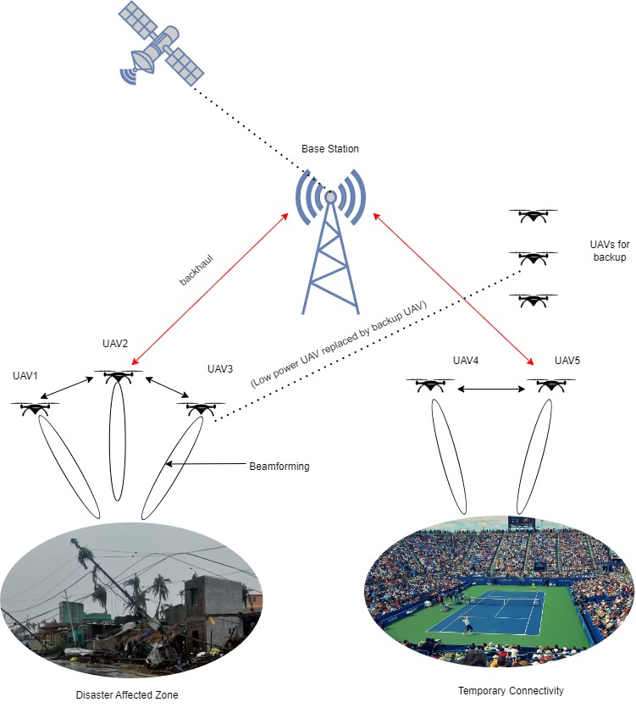

Fig. 1 Post-disaster/emergency UAV-assisted wireless communication network

The well-known channel model, which is discussed in [11], is utilized in this paper. Links between unmanned aerial vehicles (UAVs) and ground users are anticipated to take place, both in terms of line of sight and non-line of sight. According to [26], the probability of a link between a UAV and a user being regarded as a LoS is calculated as

$$P_{LoS}=\frac{1}{1+d_{1} exp\left(-d_{2}\left(\frac{180}{π}\tan^{-1}\left(\frac{h_{c}}{r_{u_{c}}^{c}}\right)-d_{1}\right)\right)} (1)$$

The environment is responsible for determining the constant vales 𝑑1 and 𝑑2 in this equation. The horizontal Euclidean distance between 𝑢𝑐nd UAV𝑐 is

${r_{u}^{c}}_{c}=\sqrt{h_{c}^{2}+[x_{c}-x_{u_{c}}]^{2}+ [y_{c}-y_{u_{c}}]^{2}}$ used to estimate the distance between the two entities. The equation that is used to estimate the likelihood of NLoS is derived by subtracting the value of NLoS from the value of NLoS. Based on the information provided in [11], it is anticipated that the average route loss between user 𝑢𝑐 and UAV 𝑐 will be as follows:

$$L_{u_{c}}^{c}=K_{0}d_{u_{c}}^{c} φ\left[P_{LoS} μ_{LoS}+P_{NLoS}μ_{NLoS}\right] (2)$$

Where,

${d_{u}^{c}}_{c}=\sqrt{h_{c}^{2}+[x_{c}-x_{u_{c}}]^{2}+ [y_{c}-y_{u_{c}}]^{2}}$ is the distance between the user 𝑢c and the unmanned aerial vehicle (UAV c), $K_{0}={\left(\frac{4πc_{f}}{s}\right)}^{2},$ 𝜑 is the constant for the path loss proponent, $c_{f}$ is the frequency of the carrier, $μ_{LoS}$ and $μ_{NLoS}$ are the attenuation (loss) factors for the local area network (LoS) and NLoS connections, respectively, and 𝑠 represents the light speed. This equation, which states that the channel gain 𝑔𝑐 average route loss, may be found in [25].

$g_{u_{c}}^{c}$ = $\frac{1}{L_{u_{c}}^{c}}$ (3)

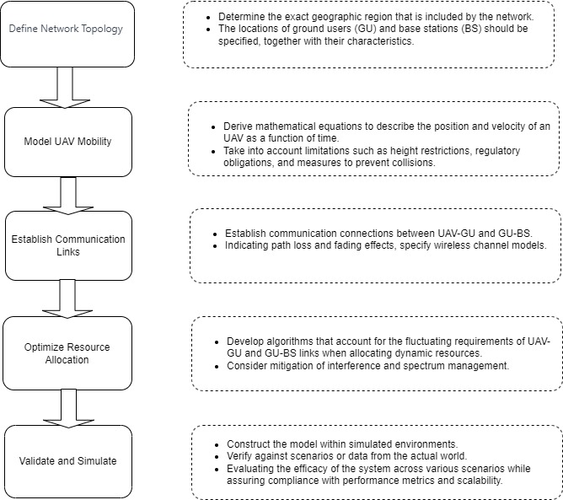

Fig.2 Flow chart of deployment of UAV as a base station in wireless communication Network

IV. RESULT AND DISCUSSION

Simulation graph Plotted against the signal-to-noise ratio (SNR) for two transmit antennas, the frame error rate (FER) performance of various deployment models (UAVs to UAVs, Base station to UAVs, Satellite to Base Station) is displayed in Fig. 3. There are various IMT advanced operating environment deployment models in use. Since RF

transmission will be necessary in the future while adopting broadband technology. Multiple input multiple output systems are required when radio channels can be used in any way to increase FER while still being affordable and effective. The base transceiver station (BTS) height is maintained at a little higher level than the surrounding workplaces. The bricks may be arranged differently or form a grid-like layout. Propagation conditions for nonline-of-sight/ line-of-sight to diffraction effects for nonline-of-sight and direct for line-of-sight. By modeling the system, we compare the results, as the distance increases (Satellite to base station comparisons to UAVs to UAVs and Base station to UAVs) FER is more and becomes better as the distance decreases for a particular threshold limit, thus the signal-to-noise ratio increases, and consequently, FER is reduced, as the distance decreases for the optimum positioning of UAVs. Fig. 3 Performance Evaluation of Different Deployment Models.

REFERENCES

[1] Ning, Zhaolong, Peiran Dong, Xiaojie Wang, Xiping Hu, Lei Guo, Bin Hu, Yi Guo, Tie Qiu, and Ricky YK Kwok. "Mobile edge computing enabled 5G health monitoring for Internet of medical things: A decentralized game theoretic approach." IEEE Journal on Selected Areas in Communications 39, no. 2 (2020): 463-478.

[2] Sharma, Rahul, Shakti Raj Chopra, and Akhil Gupta. "Power Optimization of Unmanned Aerial Vehicle-Assisted Future Wireless Communication Using Hybrid Beamforming Technique in Disaster Management." In *IOP Conference Series: Earth and Environmental Science*, vol. 1285, no. 1, p. 012025. IOP Publishing, 2024..

[3] Liu, Jianqi, Jiafu Wan, Dongyao Jia, Bi Zeng, Di Li, Ching-Hsien Hsu, and Haibo Chen. "High-efficiency urban traffic management in context-aware computing and 5G communication." IEEE Communications Magazine 55, no. 1 (2017): 34-40.

[4] Liu, Jianqi, Jiafu Wan, Dongyao Jia, Bi Zeng, Di Li, Ching-Hsien Hsu, and Haibo Chen. "High efficiency urban traffic management in context-aware computing and 5G communication." IEEE Communications Magazine 55, no. 1 (2017): 34-40.

[5] Darwish, Ashraf, Aboul Ella Hassanien, Mohamed Elhoseny, Arun Kumar Sangaiah, and Khan Muhammad. "The impact of the hybrid platform of internet of things and cloud computing on healthcare systems: opportunities, challenges, and open problems." Journal of Ambient Intelligence and Humanized Computing 10 (2019): 4151-4166.

[6] Akram, T.; Awais, M.; Naqvi, R.; Ahmed, A.; Naeem, M.: Multicriteria uav base stations placement for disaster management. IEEE Syst. J. 14(3), 3475–3482 (2020)

[7] Alzenad, Mohamed, Amr El-Keyi, Faraj Lagum, and Halim Yanikomeroglu. "3-D placement of an unmanned aerial vehicle base station (UAV-BS) for energy-efficient maximal coverage." IEEE Wireless Communications Letters 6, no. 4 (2017): 434-437.

[8] Chopra, Shakti Raj, Tadiboyina Teja, Rudru Gowtham, Gompa Dileep Kumar, Tati Sai Vivek, and Kakumanu Venkateswarlu. "Moving Object Detection Using Satellite Navigation System." In *Artificial Intelligence and Machine Learning in Satellite Data Processing and Services: Proceedings of the International Conference on Small Satellites, ICSS 2022*, pp. 99-108. Singapore: Springer Nature Singapore, 2023..

[9] Lyu, Jiangbin, Yong Zeng, and Rui Zhang. "UAV-aided offloading for cellular hotspot." IEEE Transactions on Wireless Communications 17, no. 6 (2018): 3988-4001.

[10] Chopra, Shakti Raj, Parulpreet Singh, Ahmed Alhussen, Nitin Mittal, and MohdAnul Haq. "Power Optimized Multiple-UAV Error-Free Network in Cognitive Environment." *Computers, Materials & Continua* 75, no. 2 (2023).

[11] Li, Xiaowei, Haipeng Yao, Jingjing Wang, Xiaobin Xu, Chunxiao Jiang, and Lajos Hanzo. "A near-optimal UAV-aided radio coverage strategy for dense urban areas." IEEE Transactions on Vehicular Technology 68, no. 9 (2019): 9098-9109